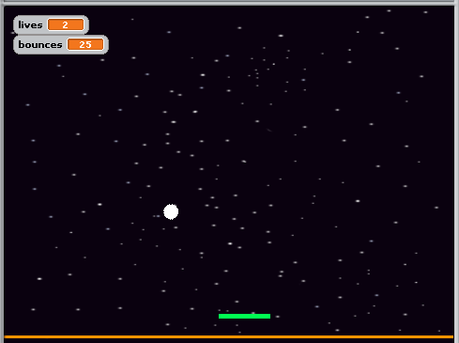 | Pong  Control the paddle using the mouse. 3 lives – if the ball touches the floor, you loose a life. It also shows the number of times the ball bounces.
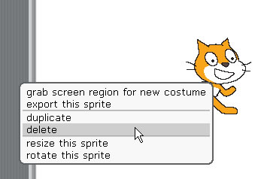 | RIGHT mouse click on the cat and select 'delete'
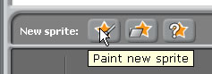 | Click on the 'new sprite' button
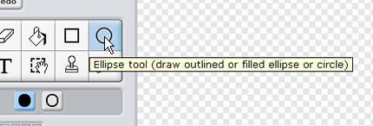 | Select the Ellipse tool  Make sure the 'solid' fill is selected below
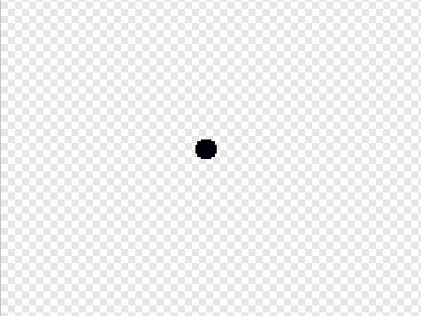 | Draw a very small ellipse (holding down SHIFT) will make sure it's a perfect circle.  Click OK.
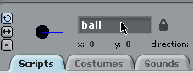 | With the sprite selected, rename it to ‘ball’
 | Now for the paddle… click ‘Paint new sprite’.
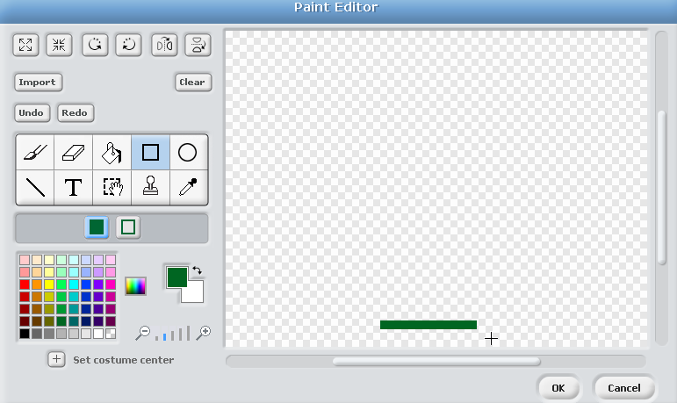 | Draw a small paddle using the rectangle tool, in a colour of your choice.
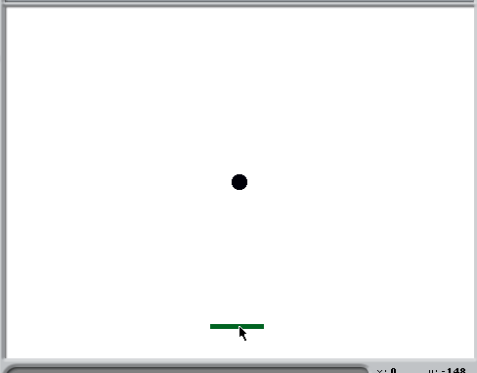 | Click and drag the paddle towards the bottom of the stage.
 | Rename the paddle sprite to ‘paddle’.
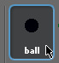 | Click on the ‘ball’ sprite
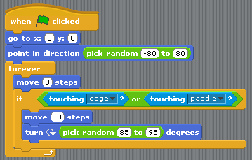 | Add the code as shown.  When the flag is clicked, the ball will ALWAYS shoot upwards in a random direction.  Those physicists amongst you will realise that we’re not using the proper laws of physics!  Press the green flag to test it so far…
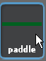 | Click on the paddle.
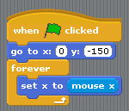 | Add the script as shown.  The paddle will be controlled by the mouse.

 | Keeping track of the number of ‘lives’…
Click on ‘Variables’.

A variable stores the value of something. We might have variables to store the number of ‘lives’, ‘score’ or someone’s name.
 | Click ‘Make a variable’
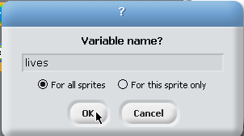 | Type in ‘lives’ and click ‘ok’.
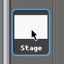 | Click on the ‘stage’
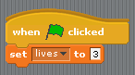 | Add blocks as shown.
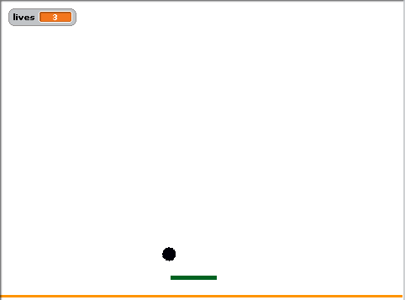 | Create another sprite, call it ‘floor’. This is a rectangle at the bottom of the screen.
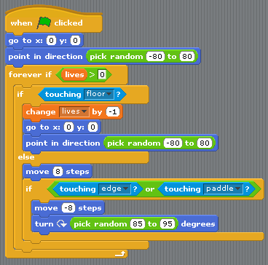 | Change the blocks on the ball sprite to as follows:
Save.
Try it out!
 | TASK: Add a ‘bounces’ variable, that keeps score of how many times the ball bounces.
 | TASK: modify the theme.

Finished this? Try creating another game: ‘Catch the egg’. An egg (or similar object) falls from the top. When you click on it, it glides to a random position at the top of the screen and begins to fall again, but a little faster. If you catch it 6 times, you win. If the egg touches the floor, you loose.

